Chouteau Chamber of Commerce
P.O. Box 332
Chouteau, Oklahoma 74337
918.476.8222

Membership Application
We would like to thank you for your consideration of joining the Chouteau Chamber of Commerce for the 2024 physical year. Below is the breakdown of how you can choose to split your membership fees and be featured at some of the Chamber sponsored events this year.
Membership term is for one (1) year- January to December.
Please select Membership Level and Event Sponsorships below and enclose amount with Application.
INDIVIDUAL MEMBERSHIP DUES:
Senior Citizen Dues $15.00
Individual $20.00
Family $30.00
BUSINESS MEMBERSHIP DUES:
Civic / Non - Profit Organization $30.00
Business $50.00
PREMIUM MEMBERSHIP DUES:
Silver Membership $75.00
Gold Membership $125.00
Platinum Membership $250.00
Community Development Partner $1000.00
DUES FEE AMOUNT AND LEVEL:________________________________________________________
Event Sponsorships:
Min is the Minimum Amount Sponsorship and Top is the Total Amount needed to Fully Sponsor an Event.
Taco Tuesday Social Networking $25 Min and $500 Top Amount:
2nd Annual Corn Hole Tournament $25 Min and $500 Top Amount:
Christmas in July at the Park $75 Min and $ 1000 Top Amount:
Car Show on Main $30 Min and $100 Top Amount:
Football Homecoming Bonfire on Main Street $25 Min and $1000 Top Amount:
Trunk at Trunk or Treat $25 Min and $300 Top Amount:
Chouteau Chamber Christmas Parade and Goose Grab $50 Min and $3000 Top Amount:
Dream Big Event $50 Min and $1000 Top Amount:__________________________________________
TOTAL $__________

Contact Person:
Mailing Address:
City: State: Zip Code:
Contact’s Phone:
Email:
Tell Us About Your Business:

Please Make Check out to Chouteau Chamber of Commerce
Checks and Application Can be mailed to PO BOX 332
Chouteau, Oklahoma 74337
Or Dropped off at Welch State Bank or Frailey’s Recycling
For more details on your membership please visit our website at https://www.chouteauchamber.com/membership

2024 Event List

Taco Tuesday Social Networking
When: Feb 20 ^{th} 6-7:30
Where: Casa Maria’s
This event is open to all chamber members to come and mingle at an informal setting. Appetizers and non-acholic drinks will be provided courtesy of the chamber.
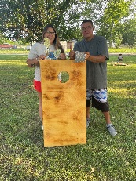
2nd Annual Corn Hole Tournament
When: June TBA
Where: Main Street Park
We would like to invite everyone to a Corn Hole Tournament at the Main Street Park. What fun!
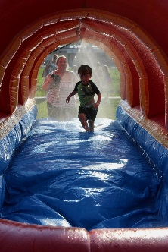
Christmas in July at the Park
When: July 25th
Where: Chouteau Park
Water balloon fights, Inflatables, food!
This will be a BIG event for the chamber! We want to beat the heat and have some Christmas fun with the community! We will need donations and volunteers.

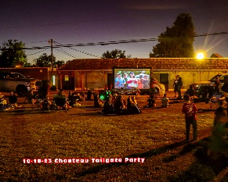
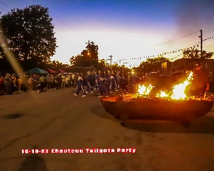
Football Homecoming Bonfire on Main Street
When: September 12
Where: Main Street Park
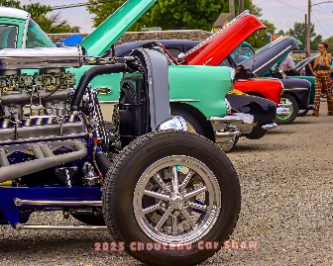
We plan on inviting the football team, cheerleaders, band members, little league, and community to come out and enjoy the bonfire! The chamber will provide hotdogs, popcorn, and bottled water.
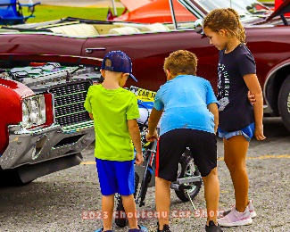
Car Show on Main
When: September 21st 10pm-1pm
Where: Main Street
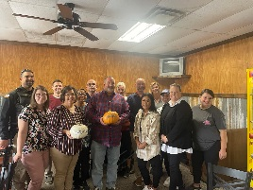
This will be our Third Annual Car Show and there is a lot of ways to incorporate your business into the show if you choose to sponsor; whether it be a side prize, banner, etc. Last year was a GREAT success and really added to Black Buggy Days and Picking the Line on 69.

Pass the Pumpkins
EVERY business has a chance to take the chamber pumpkins to their businesses and show them off. Let the town know that you’re a Chamber Member and pumpkin proud!
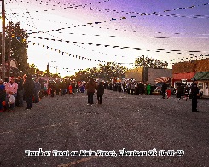
Trunk at Trunk or Treat
When: October 26th 5-7pm
Where: Main Street
Each year there is a Trunk or Treat on Main Street and last year the chamber joined with Little League Football and passed out candy.

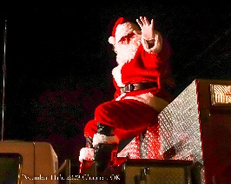
Chouteau Chamber Christmas Parade
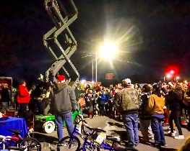
and Goose Grab
When: Dec 9th
Where: Main Street
This is a time-honored tradition that the chamber has been presenting for years. The businesses really gear up to show their creativity with their floats. Chouteau Fire Department hands out candy and helps Santa. And the Goose Grab is by far the most FUN event the chamber has been involved with. We gave away 10 frozen turkeys last year and over $400 dollars in local gift cards to really support our local businesses.

Dream Big Event
When: TBA
Where: TBA
This will be a new event for the Chamber of Commerce. The Chamber plans to partner with Chouteau Schools and find out what event the kids would like to see in Chouteau. We want a host the event that the kids pick. We at the Chamber want our kids to know that Chouteau is a fun and safe town to live in.

